Data Structures (2028C) **Lab 8**

Fall 2020Topics covered***: Binary Trees***

(week of 10/27-29/20)

**Objective:**

The objective of this Lab is to explore creating and using a binary tree.

The international Morse code, which was used in telegraphy in an early era of telecommunication and is still extensively used today in the ham radio community, encodes messages composed with letters by using dots (short pulses) and dashes (long pulses). The encoding scheme is based on a study of the frequency of occurrence in texts, where the most frequently used letters have the least number of pulses in their encoding.

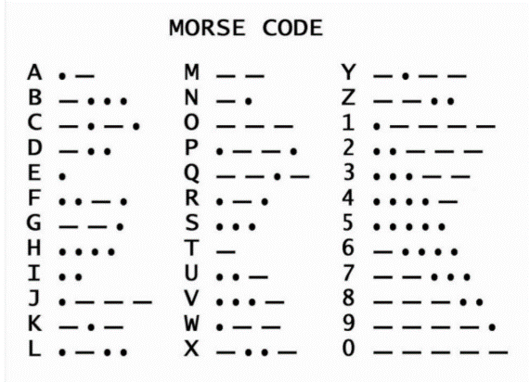 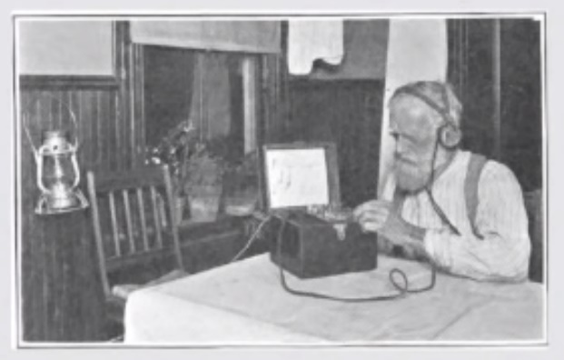

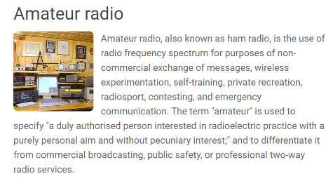 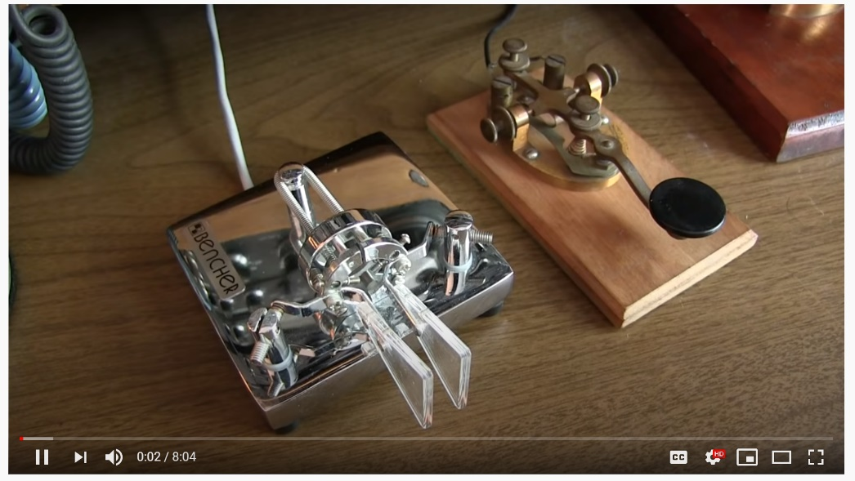

<https://www.youtube.com/watch?v=78VXLVZckIQ>

Morse code tree can be represented by a static binary tree (BT), where binary values of ‘.’ and ‘-‘ indicate the order of the children nodes, ‘.’ for the left child and ‘-‘ the right child, respectively, and the leaf nodes are the characters encoded by the sequence of pulses traversed through the tree, starting from the root node. For instance, to get the letter ‘L’ the route through the nodes is root, left child, right child, left child, left child, the last node being the leaf node containing the encoded letter. Using the asterisk symbol for dot, the path would be .- . . L

**Task 1:** Design a binary tree class and implement the basic operations for inserting, finding, and deleting nodes.

**Task 2:** Design a strategy to build a Morse Code Binary Tree for the 26 alphabet letters using the encoding scheme provided by the Morse code.

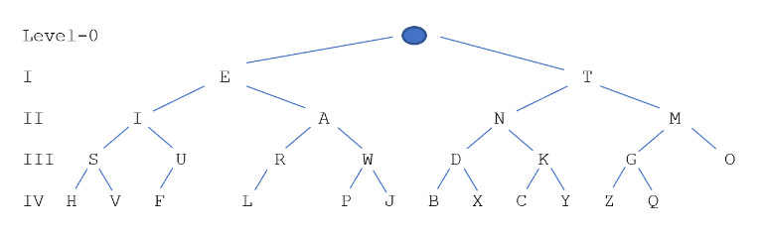

**Milestone : print the tree**

**Task 3:** Create a test program using one of the three tree traversal ways to a) read in the morse code (i.e., the sequence of dots, dashes, and separator spaces) and print out the message, and b) provide a message in words and printout the corresponding Morse code.

**Lab Submission:**

1. Write a lab report including the following information:
   1. A description of the objectives/concepts explored in this assignment including why you think they are important to this course and a career in CS and/or Engineering.
   2. The sections from each task indicated to be included in the lab report.
2. Include all source code from all tasks, input and output files (if any), and any special instructions to compile and run those programs.

**Lab Grading:**

1. 20% - Lab attendance
2. 20% - Task 1 has been correctly implemented and meets all requirements.
3. 30% - Task 2 has been correctly implemented and meets all requirements.
4. 30% - Task 3 has been correctly implemented and meets all requirements.

If program fails to compile, 0% will be given for that Task.

Node found

O

M

Q

G

Z

T

Y

K

C

N

X

D

B

ROOT

J

W

P

A

R

L

E

U

F

I

V

S

H

Level-0

I E T

II I A N M

III S U R W D K G O

IV H V F L P J B X C Y Z Q

V 5 4 3 2 1 6 7 8 9 0

 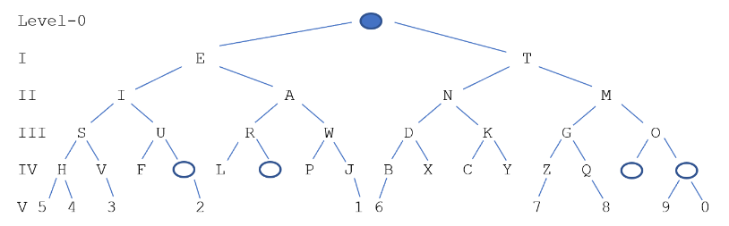

Level-0

I E T

II I A N M

III S U R W D K G O

IV H V F L P J B X C Y Z Q

